**HOW TO PLAY??**

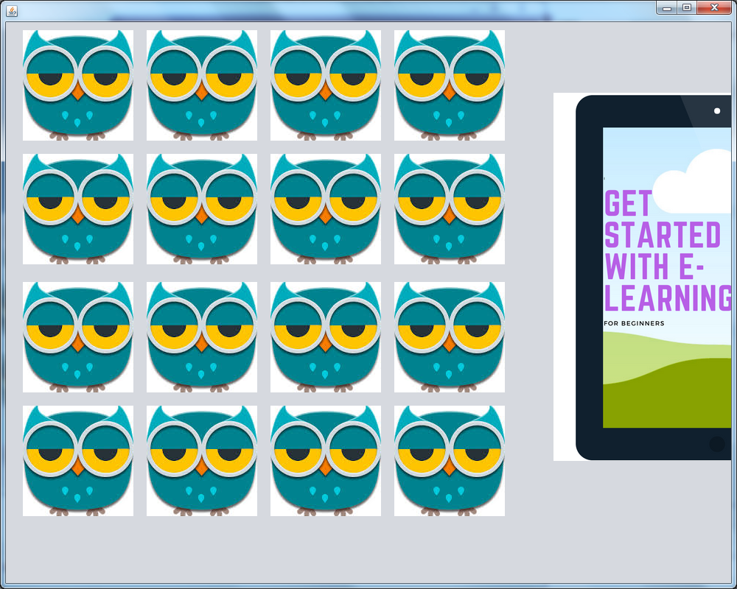

1. **Click on one of the owls.**
2. **It will show you some picture.**

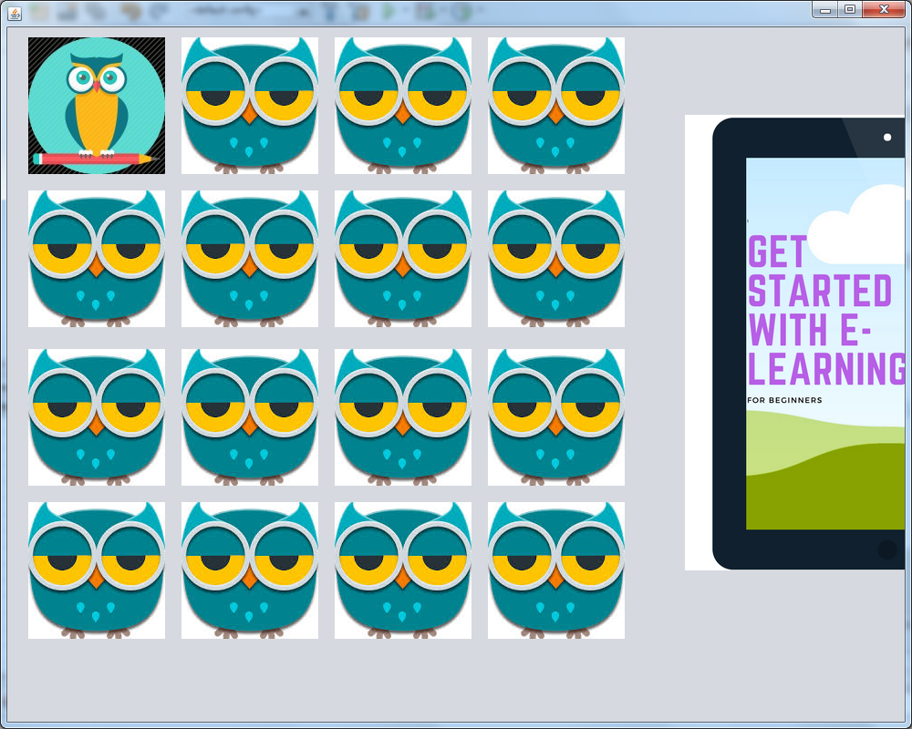

1. **Now again click on another owl.**
2. **It will show up some picture, now try to match the two picture.**
3. **If you click on the same owl twice it will reset to default and will get deselected.**
4. **If get the correct pair then will disappear.**
5. **Match all of them.**

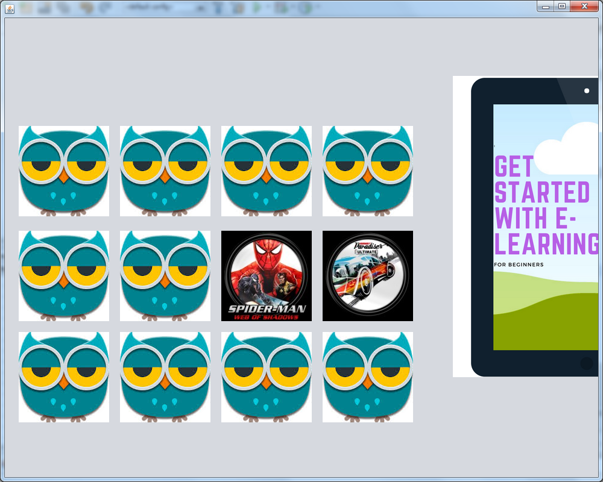

**ENJOY!!!^_^**

